Geometric Construction in Solid Geometry

Definition
# Source: AI Source: Provided by: [Data Path: Persons Table -> ID Column: 1, Name_En Column: Motasem Essam] -> From: [ChatGPT] on [7/25/2026]
Geometric Construction in Solid Geometry is the process of creating, forming, or determining three-dimensional geometric objects using defined geometric elements, mathematical relationships, construction methods, and spatial operations.
It involves constructing points, line segments, lines, planes, surfaces, and solids according to specific geometric conditions.
Geometric construction can be performed using traditional geometric instruments, mathematical methods, physical models, or computer-aided geometric design tools.
Unlike plane geometric construction, which focuses primarily on two-dimensional figures, solid geometric construction deals with three-dimensional forms and their spatial relationships.

Geometric Representation
# Source: AI Source: Provided by: [Data Path: Persons Table -> ID Column: 1, Name_En Column: Motasem Essam] -> From: [ChatGPT] on [7/25/2026]
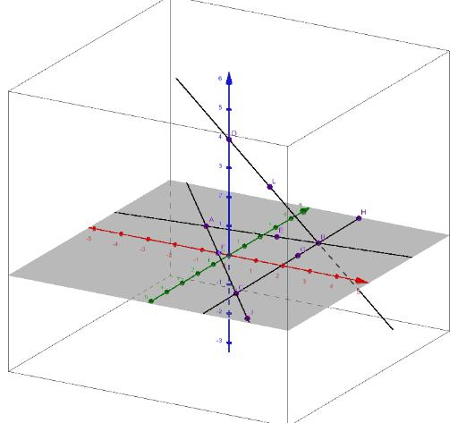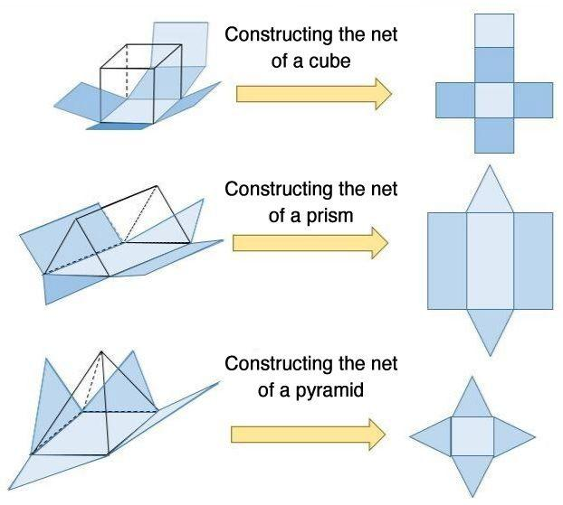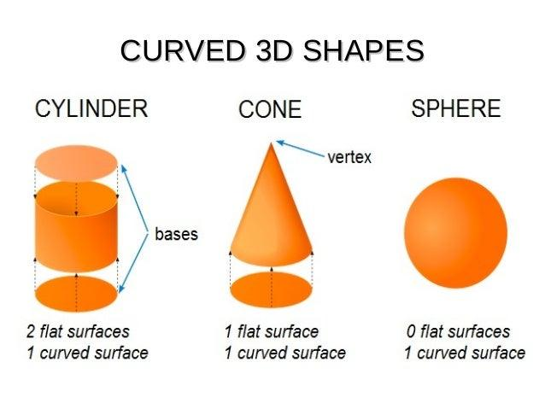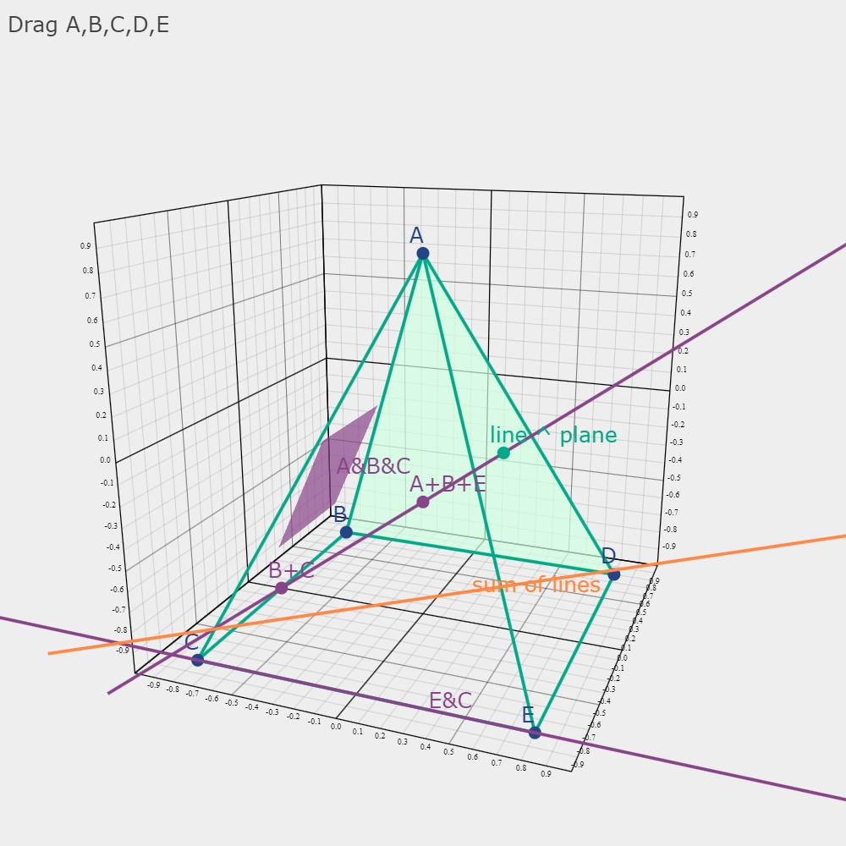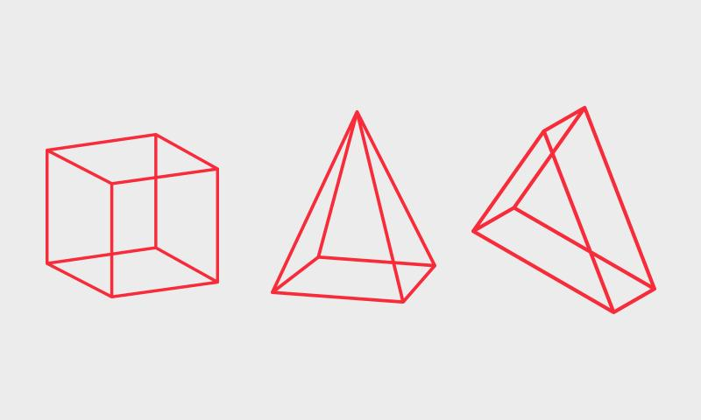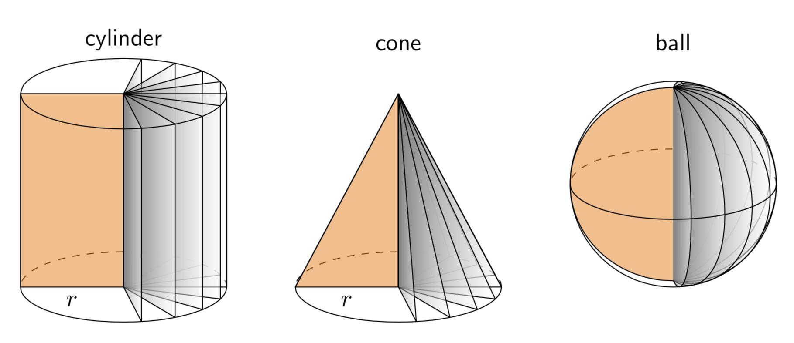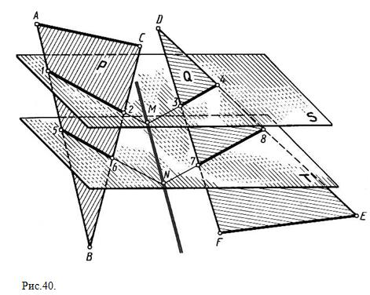
Geometric construction involves several fundamental elements:
- Points: Define specific positions in three-dimensional space.
- Line Segments: Define finite straight portions between two endpoints.
- Lines: Define infinite straight paths through space.
- Planes: Define flat two-dimensional surfaces in space.
- Angles: Define relationships between intersecting lines, planes, and directions.
- Surfaces: Define the boundaries of geometric objects.
- Solids: Define three-dimensional enclosed regions.
- Geometric Transformations: Modify the position, orientation, or dimensions of geometric objects.

Geometric Structure
# Source: AI Source: Provided by: [Data Path: Persons Table -> ID Column: 1, Name_En Column: Motasem Essam] -> From: [ChatGPT] on [7/25/2026]
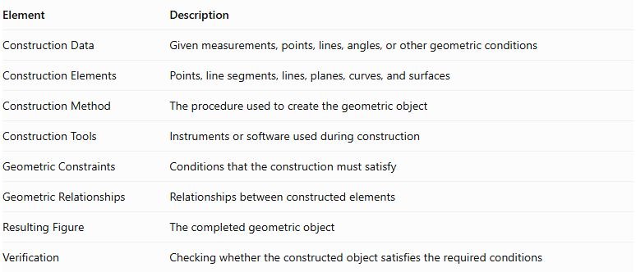
Element | Description
Construction Data | Given measurements, points, lines, angles, or other geometric conditions
Construction Elements | Points, line segments, lines, planes, curves, and surfaces
Construction Method | The procedure used to create the geometric object
Construction Tools | Instruments or software used during construction
Geometric Constraints | Conditions that the construction must satisfy
Geometric Relationships | Relationships between constructed elements
Resulting Figure | The completed geometric object
Verification | Checking whether the constructed object satisfies the required conditions

Main Characteristics
# Source: AI Source: Provided by: [Data Path: Persons Table -> ID Column: 1, Name_En Column: Motasem Essam] -> From: [ChatGPT] on [7/25/2026]
- Geometric construction follows defined mathematical relationships.
- It can produce points, line segments, lines, planes, surfaces, and three-dimensional solids.
- It can be performed using geometric instruments or computational methods.
- It may begin with given dimensions, coordinates, angles, or geometric elements.
- It can involve combining multiple geometric components.
- It can involve transformations such as translation, rotation, reflection, and scaling.
- It can be used to construct regular, irregular, convex, concave, and composite solids.
- The resulting construction must satisfy its specified geometric constraints.

Types of Geometric Construction in Solid Geometry

According to Constructed Geometric Element

Point Construction
# Source: AI Source: Provided by: [Data Path: Persons Table -> ID Column: 1, Name_En Column: Motasem Essam] -> From: [ChatGPT] on [7/25/2026]
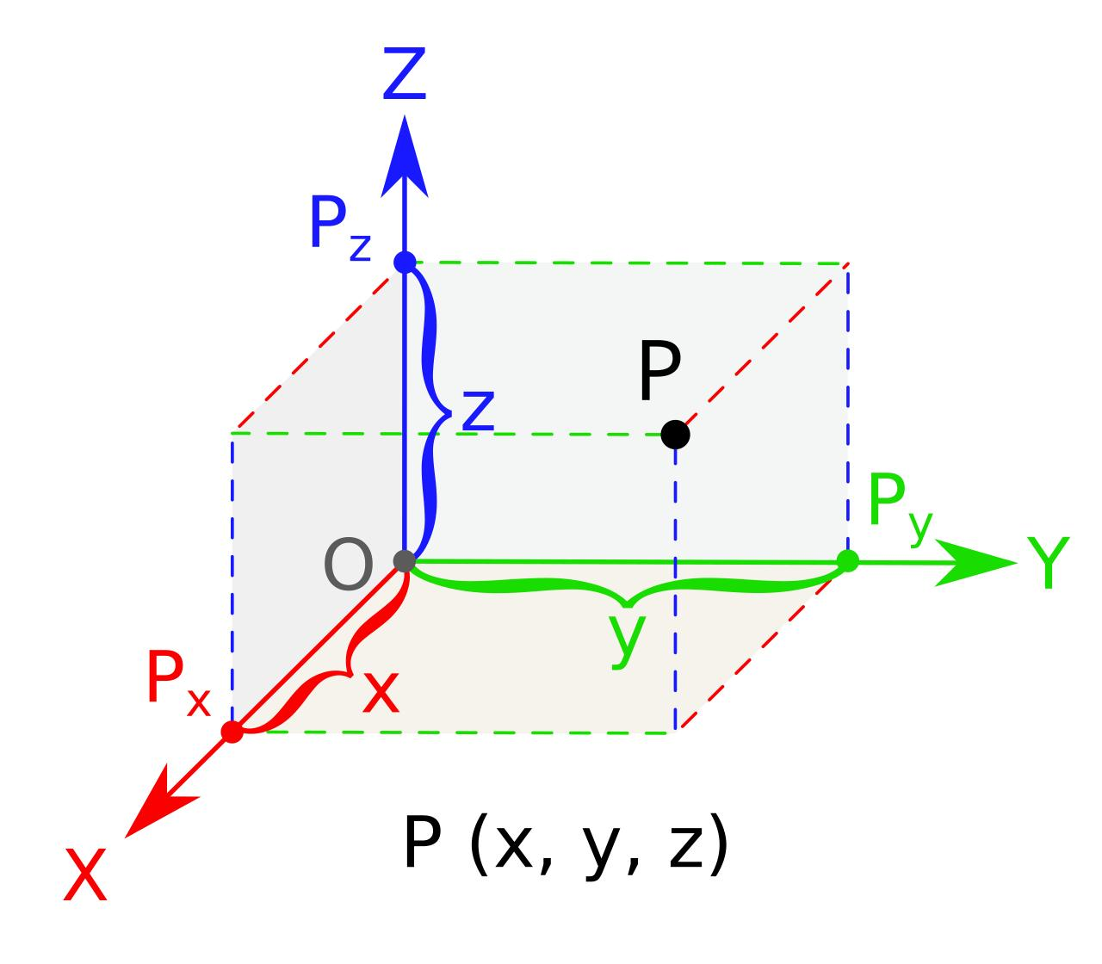
Point Construction is the process of determining and representing specific locations in three-dimensional space according to given coordinates, geometric relationships, or construction conditions.
Examples:
- Coordinate Point Construction
- Intersection Point Construction
- Midpoint Construction
- Equidistant Point Construction
- Collinear Point Construction
- Coplanar Point Construction
- Symmetrical Point Construction
- Point of Tangency Construction
- Point of Projection Construction
Mathematical Representation
A point in three-dimensional Cartesian space is represented by:
$$P=(x,y,z)$$
Where:
- $x$: horizontal coordinate.
- $y$: depth coordinate.
- $z$: vertical coordinate.
The distance between two constructed points is:
$$AB=\sqrt{(x_{2}-x_{1})^{2}+(y_{2}-y_{1})^{2}+(z_{2}-z_{1})^{2}}$$

Line Segment Construction
# Source: AI Source: Provided by: [Data Path: Persons Table -> ID Column: 1, Name_En Column: Motasem Essam] -> From: [ChatGPT] on [7/25/2026]
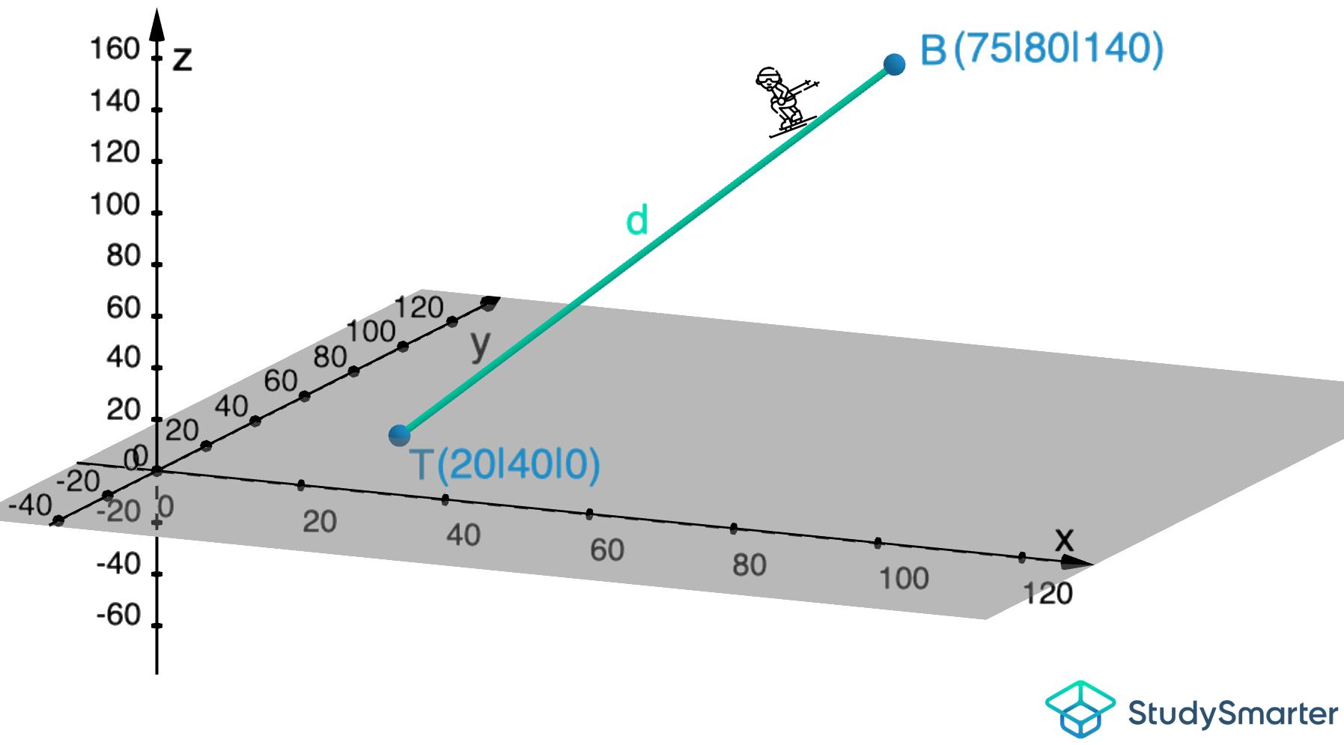
Line Segment Construction is the process of constructing a finite straight portion between two distinct endpoints in three-dimensional space.
A line segment has a definite length and two endpoints.
Examples:
- Basic Line Segment Construction
- Given-Length Line Segment Construction
- Connecting Two Points Construction
- Congruent Line Segment Construction
- Perpendicular Line Segment Construction
- Parallel Line Segment Construction
- Midpoint-Based Line Segment Construction
- Divided Line Segment Construction
- Equal-Division Line Segment Construction
- Ratio-Based Line Segment Construction
- Diagonal Construction
- Space Diagonal Construction
Mathematical Representation
A line segment with endpoints:
$$A=(x_{1},y_{1},z_{1})$$
$$B=(x_{2},y_{2},z_{2})$$
Its length is:
$$AB=\sqrt{(x_{2}-x_{1})^{2}+(y_{2}-y_{1})^{2}+(z_{2}-z_{1})^{2}}$$
Its parametric representation is:
$$P(t)=A+t(B-A), 0≤t≤1$$
Where:
- $A,B$: endpoints.
- $t$: parameter defining a position along the segment.
- $P(t)$: any point on the segment.

Line Construction
# Source: AI Source: Provided by: [Data Path: Persons Table -> ID Column: 1, Name_En Column: Motasem Essam] -> From: [ChatGPT] on [7/25/2026]
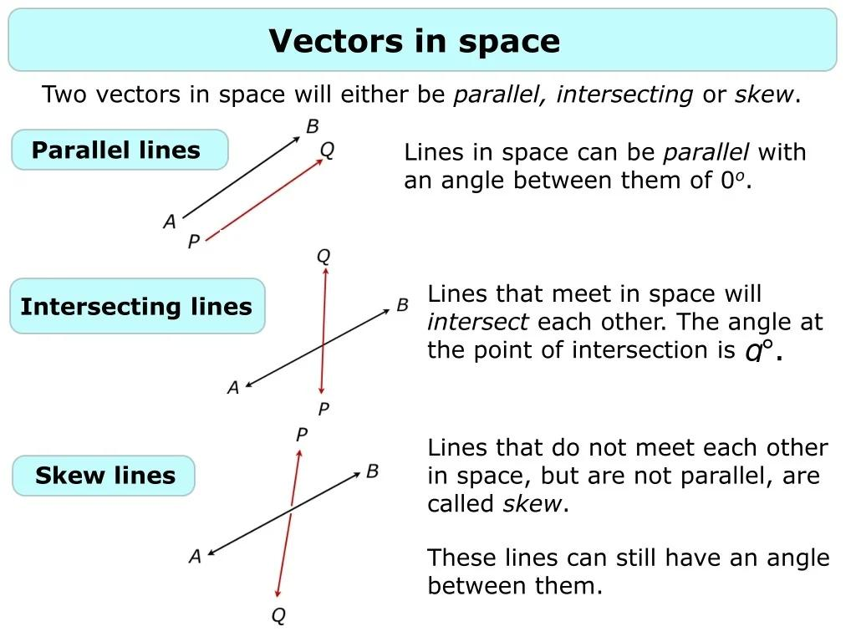
Line Construction is the process of constructing an infinite straight path in three-dimensional space using given points, directions, or geometric relationships.
Examples:
- Line Through Two Points Construction
- Parallel Line Construction
- Perpendicular Line Construction
- Intersecting Line Construction
- Skew Line Construction
- Horizontal Line Construction
- Vertical Line Construction
- Inclined Line Construction

Plane Construction
# Source: AI Source: Provided by: [Data Path: Persons Table -> ID Column: 1, Name_En Column: Motasem Essam] -> From: [ChatGPT] on [7/25/2026]
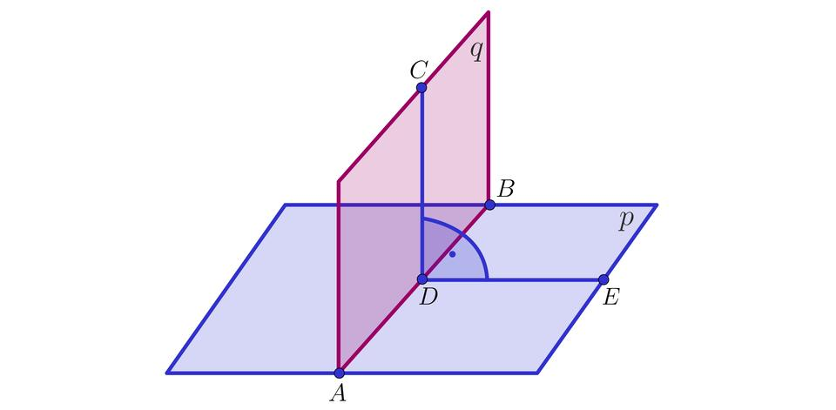
Plane Construction is the process of determining and representing a flat two-dimensional surface in three-dimensional space.
Examples:
- Plane Through Three Non-Collinear Points Construction
- Parallel Plane Construction
- Perpendicular Plane Construction
- Intersecting Plane Construction
- Horizontal Plane Construction
- Vertical Plane Construction
- Oblique Plane Construction
- Tangent Plane Construction

Surface Construction
# Source: AI Source: Provided by: [Data Path: Persons Table -> ID Column: 1, Name_En Column: Motasem Essam] -> From: [ChatGPT] on [7/25/2026]
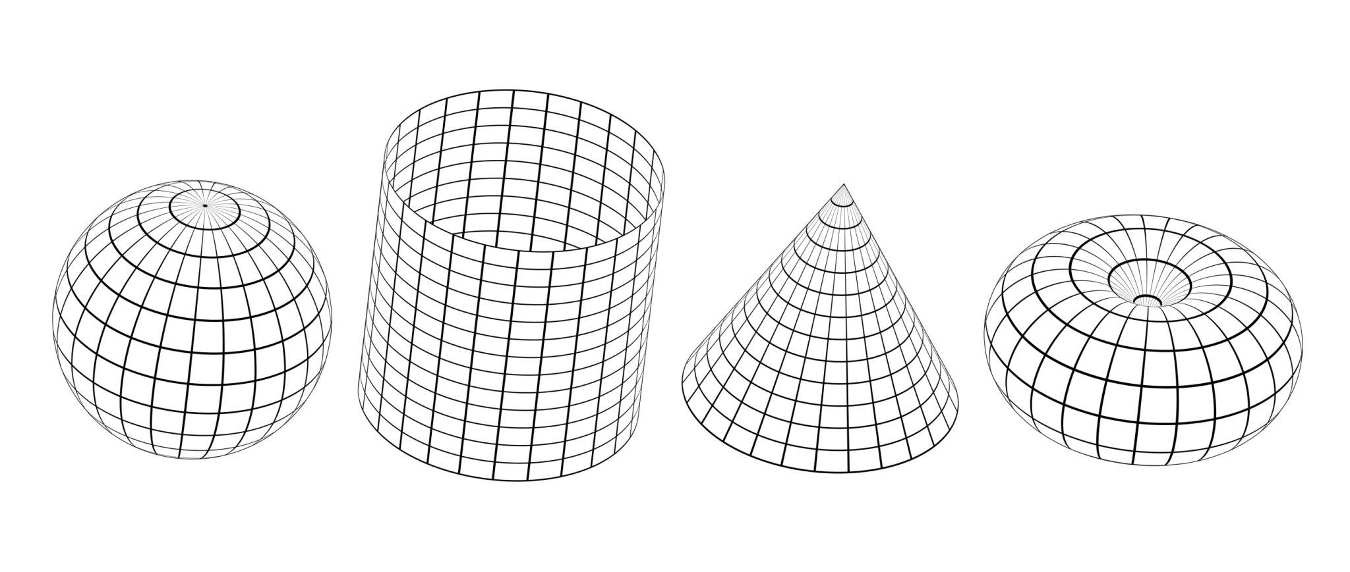
Surface Construction is the process of creating flat or curved two-dimensional surfaces in three-dimensional space.
Examples:
- Plane Surface Construction
- Cylindrical Surface Construction
- Conical Surface Construction
- Spherical Surface Construction
- Conic Surface Construction
- Ruled Surface Construction
- Revolved Surface Construction
- Swept Surface Construction

Solid Construction
# Source: AI Source: Provided by: [Data Path: Persons Table -> ID Column: 1, Name_En Column: Motasem Essam] -> From: [ChatGPT] on [7/25/2026]
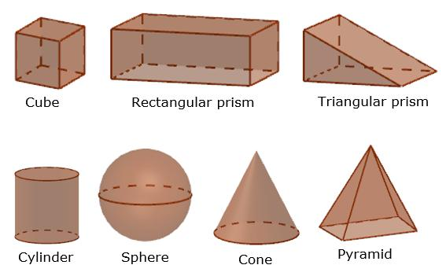
Solid Construction is the process of creating three-dimensional geometric objects with defined boundaries and volumes.
Examples:
- Polyhedron Construction
- Prism Construction
- Pyramid Construction
- Cylinder Construction
- Cone Construction
- Sphere Construction
- Torus Construction
- Composite Solid Construction

According to Construction Method

Instrument-Based Construction
# Source: AI Source: Provided by: [Data Path: Persons Table -> ID Column: 1, Name_En Column: Motasem Essam] -> From: [ChatGPT] on [7/25/2026]
Construction using physical geometric instruments.
Examples:
- Straightedge Construction
- Compass Construction
- Ruler and Compass Construction
- Set-Square Construction
- Protractor-Assisted Construction

Coordinate-Based Construction
# Source: AI Source: Provided by: [Data Path: Persons Table -> ID Column: 1, Name_En Column: Motasem Essam] -> From: [ChatGPT] on [7/25/2026]
Construction using Cartesian coordinates and mathematical equations.
Examples:
- Cartesian Coordinate Construction
- Vector-Based Construction
- Parametric Construction
- Equation-Based Construction

Projection-Based Construction
# Source: AI Source: Provided by: [Data Path: Persons Table -> ID Column: 1, Name_En Column: Motasem Essam] -> From: [ChatGPT] on [7/25/2026]
Construction using geometric projections to represent and determine three-dimensional objects.
Examples:
- Orthographic Projection Construction
- Isometric Projection Construction
- Axonometric Projection Construction
- Perspective Projection Construction
- Auxiliary Projection Construction

Transformational Construction
# Source: AI Source: Provided by: [Data Path: Persons Table -> ID Column: 1, Name_En Column: Motasem Essam] -> From: [ChatGPT] on [7/25/2026]
Construction by applying geometric transformations to existing objects.
Examples:
- Translation-Based Construction
- Rotation-Based Construction
- Reflection-Based Construction
- Scaling-Based Construction
- Shearing-Based Construction

Solid Modeling Construction
# Source: AI Source: Provided by: [Data Path: Persons Table -> ID Column: 1, Name_En Column: Motasem Essam] -> From: [ChatGPT] on [7/25/2026]
Construction of three-dimensional solids using geometric modeling operations.
Examples:
- Constructive Solid Geometry (CSG)
- Boundary Representation (B-Rep)
- Sweep-Based Construction
- Primitive-Based Construction
- Spatial Partitioning Construction
- Feature-Based Construction

Examples of Geometric Construction
# Source: AI Source: Provided by: [Data Path: Persons Table -> ID Column: 1, Name_En Column: Motasem Essam] -> From: [ChatGPT] on [7/25/2026]
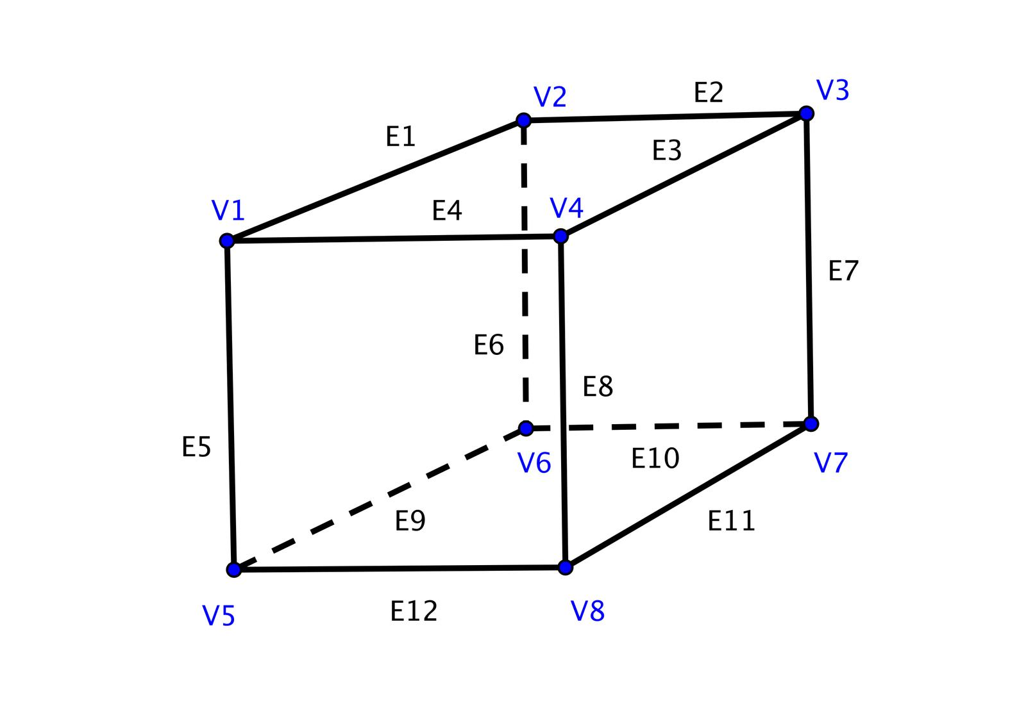
Cube Construction
Constructing a regular hexahedron from equal perpendicular edges.
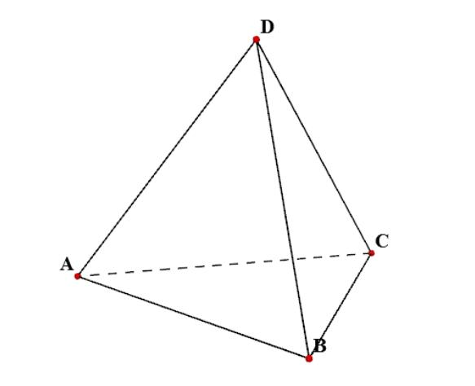
Tetrahedron Construction
Constructing a solid bounded by four equilateral triangular faces.
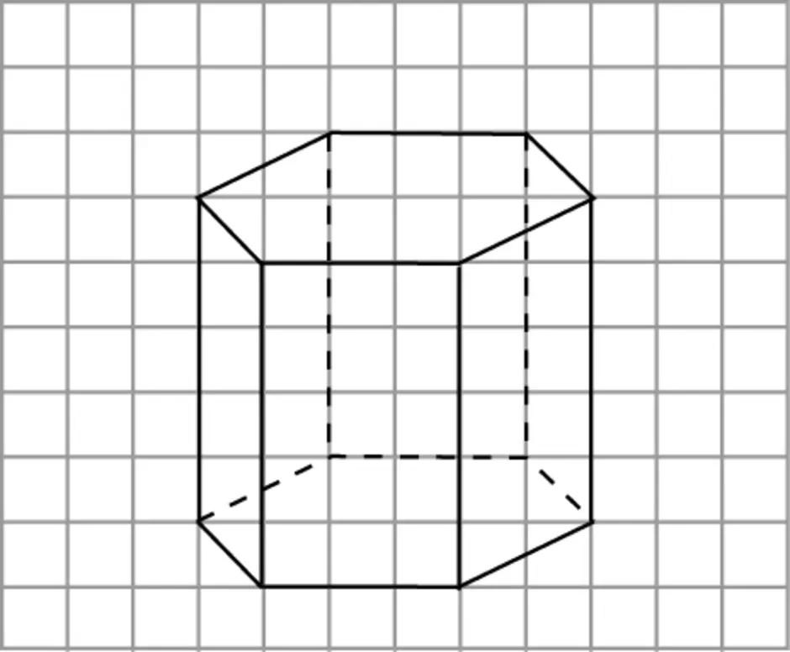
Prism Construction
Constructing a solid using two congruent parallel polygonal bases and connecting lateral faces.
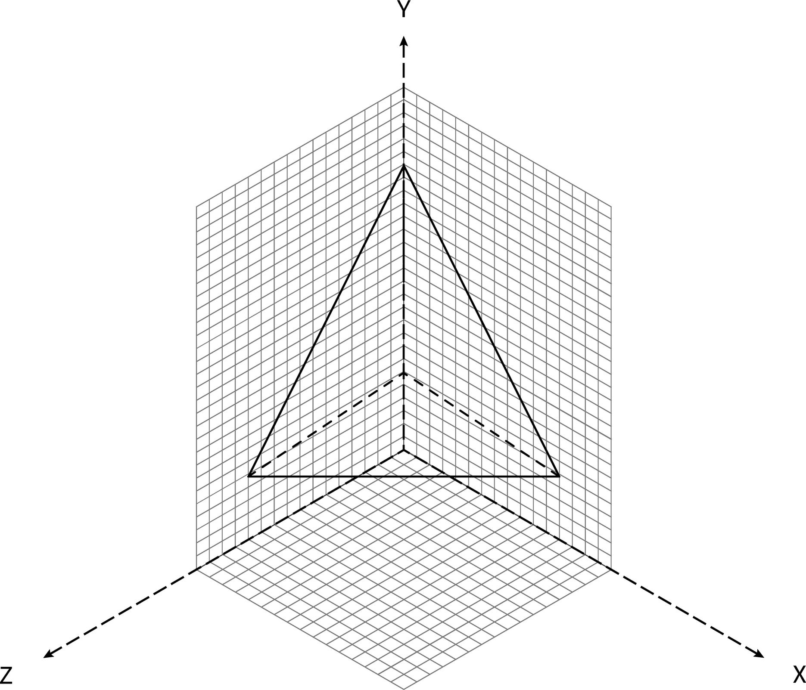
Pyramid Construction
Constructing a polygonal base and connecting its vertices to an apex.
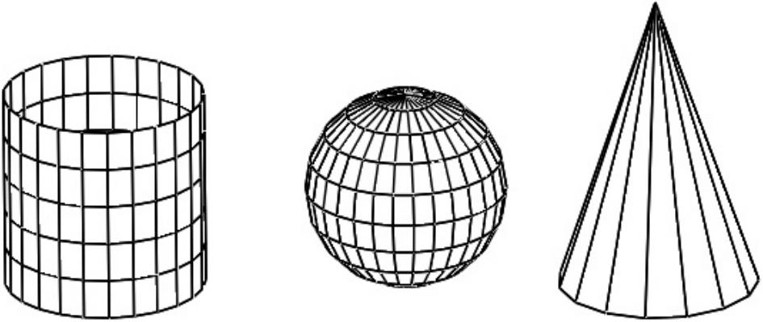
Solids of Revolution
Constructing solids by rotating plane figures or regions around an axis.
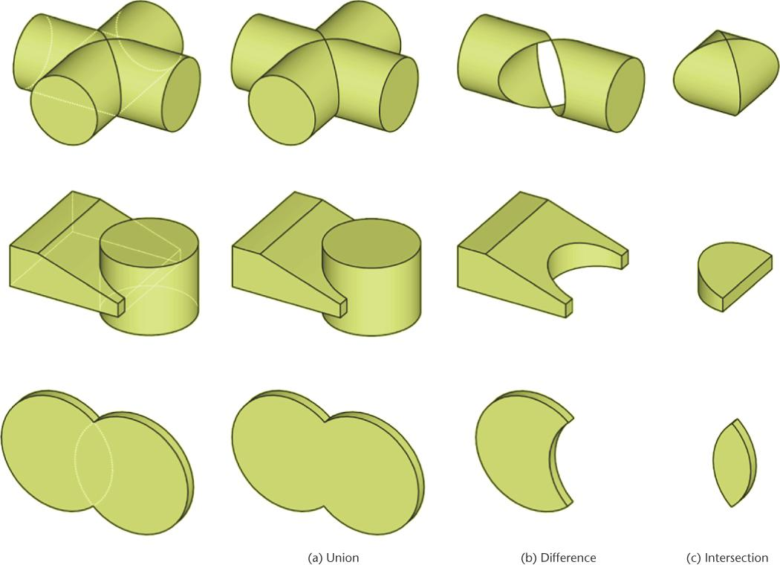
Composite Solid Construction
Constructing complex solids by combining or subtracting simpler geometric solids.

Fundamental Mathematical Relationships

Cartesian Coordinates
# Source: AI Source: Provided by: [Data Path: Persons Table -> ID Column: 1, Name_En Column: Motasem Essam] -> From: [ChatGPT] on [7/25/2026]
A point in three-dimensional space is represented by:
$$P=(x,y,z)$$

Distance Between Two Points
# Source: AI Source: Provided by: [Data Path: Persons Table -> ID Column: 1, Name_En Column: Motasem Essam] -> From: [ChatGPT] on [7/25/2026]
$$AB=\sqrt{(x_{2}-x_{1})^{2}+(y_{2}-y_{1})^{2}+(z_{2}-z_{1})^{2}}$$

Plane Equation
# Source: AI Source: Provided by: [Data Path: Persons Table -> ID Column: 1, Name_En Column: Motasem Essam] -> From: [ChatGPT] on [7/25/2026]
$$ax+by+cz+d=0$$

Line in Three-Dimensional Space
# Source: AI Source: Provided by: [Data Path: Persons Table -> ID Column: 1, Name_En Column: Motasem Essam] -> From: [ChatGPT] on [7/25/2026]
A parametric line can be represented by:
$$\vec{r}={\vec{r}}_{0}+t\vec{v}$$
Where:
- ${\vec{r}}_{0}$: position vector of a point on the line.
- $\vec{v}$: direction vector.
- $t$: real parameter.

Euler's Formula for Convex Polyhedra
# Source: AI Source: Provided by: [Data Path: Persons Table -> ID Column: 1, Name_En Column: Motasem Essam] -> From: [ChatGPT] on [7/25/2026]
$$V-E+F=2$$
Where:
- $V$: number of vertices.
- $E$: number of edges.
- $F$: number of faces.
This relationship provides a useful verification condition for convex polyhedral constructions.

Comparison with Related Concepts
# Source: AI Source: Provided by: [Data Path: Persons Table -> ID Column: 1, Name_En Column: Motasem Essam] -> From: [ChatGPT] on [7/25/2026]
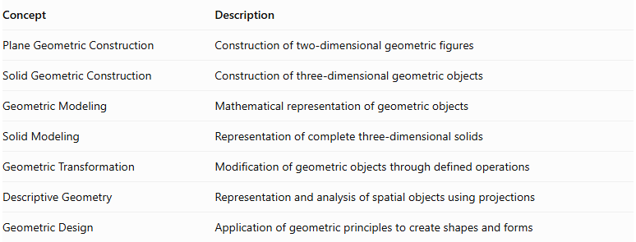
Concept | Description
Plane Geometric Construction | Construction of two-dimensional geometric figures
Solid Geometric Construction | Construction of three-dimensional geometric objects
Geometric Modeling | Mathematical representation of geometric objects
Solid Modeling | Representation of complete three-dimensional solids
Geometric Transformation | Modification of geometric objects through defined operations
Descriptive Geometry | Representation and analysis of spatial objects using projections
Geometric Design | Application of geometric principles to create shapes and forms

Applications
# Source: AI Source: Provided by: [Data Path: Persons Table -> ID Column: 1, Name_En Column: Motasem Essam] -> From: [ChatGPT] on [7/25/2026]
- Mathematics: Constructing and studying three-dimensional geometric figures.
- Architecture: Designing buildings and structural forms.
- Engineering: Constructing mechanical components and spatial structures.
- Computer Graphics: Creating three-dimensional objects and virtual environments.
- CAD: Designing and modifying precise solid models.
- Manufacturing: Preparing geometric models for production and fabrication.
- Education: Demonstrating spatial relationships and geometric properties.

Main Classification
# Source: AI Source: Provided by: [Data Path: Persons Table -> ID Column: 1, Name_En Column: Motasem Essam] -> From: [ChatGPT] on [7/25/2026]
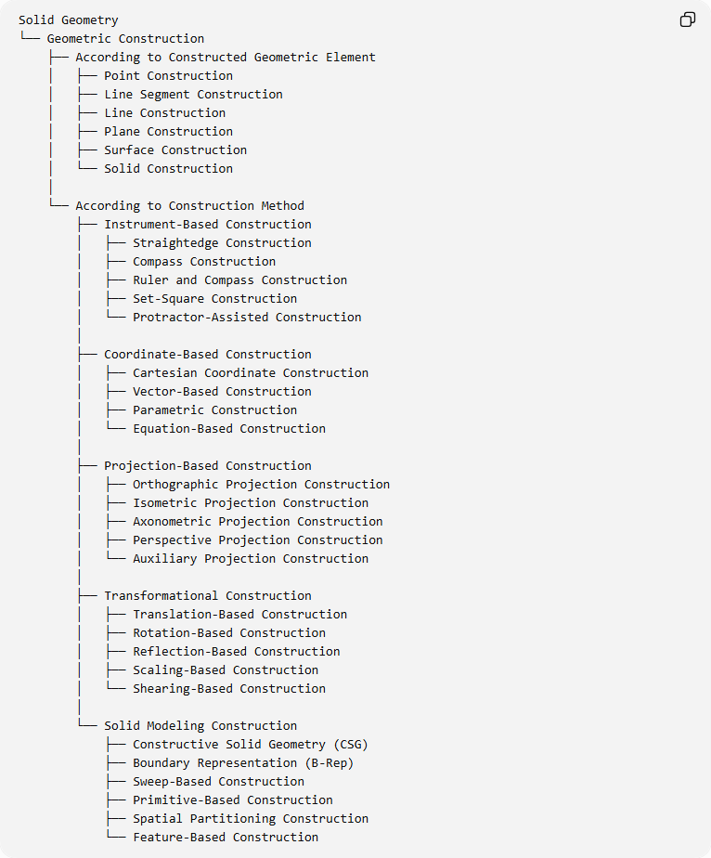
Solid Geometry
└── Geometric Construction
├── According to Constructed Geometric Element
│ ├── Point Construction
│ ├── Line Segment Construction
│ ├── Line Construction
│ ├── Plane Construction
│ ├── Surface Construction
│ └── Solid Construction
│
└── According to Construction Method
├── Instrument-Based Construction
│ ├── Straightedge Construction
│ ├── Compass Construction
│ ├── Ruler and Compass Construction
│ ├── Set-Square Construction
│ └── Protractor-Assisted Construction
│
├── Coordinate-Based Construction
│ ├── Cartesian Coordinate Construction
│ ├── Vector-Based Construction
│ ├── Parametric Construction
│ └── Equation-Based Construction
│
├── Projection-Based Construction
│ ├── Orthographic Projection Construction
│ ├── Isometric Projection Construction
│ ├── Axonometric Projection Construction
│ ├── Perspective Projection Construction
│ └── Auxiliary Projection Construction
│
├── Transformational Construction
│ ├── Translation-Based Construction
│ ├── Rotation-Based Construction
│ ├── Reflection-Based Construction
│ ├── Scaling-Based Construction
│ └── Shearing-Based Construction
│
└── Solid Modeling Construction
├── Constructive Solid Geometry (CSG)
├── Boundary Representation (B-Rep)
├── Sweep-Based Construction
├── Primitive-Based Construction
├── Spatial Partitioning Construction
└── Feature-Based Construction

Key Points
# Source: AI Source: Provided by: [Data Path: Persons Table -> ID Column: 1, Name_En Column: Motasem Essam] -> From: [ChatGPT] on [7/25/2026]
- Geometric Construction in Solid Geometry deals with creating three-dimensional geometric objects.
- Its fundamental geometric elements include points, line segments, lines, planes, surfaces, and solids.
- Point Construction and Line Segment Construction are separate construction categories.
- Construction can be performed using instruments, coordinates, projections, transformations, or solid modeling.
- Geometric construction is based on mathematical rules and spatial relationships.
- It provides the foundation for constructing simple and complex geometric solids.

Conclusion
# Source: AI Source: Provided by: [Data Path: Persons Table -> ID Column: 1, Name_En Column: Motasem Essam] -> From: [ChatGPT] on [7/25/2026]
Geometric Construction in Solid Geometry is the systematic process of creating three-dimensional geometric objects through mathematical principles and construction methods. It begins with fundamental elements such as points and line segments, progresses to lines, planes, and surfaces, and extends to the construction of complete solids. It provides the foundation for spatial visualization, geometric modeling, engineering design, and computer-aided construction.

